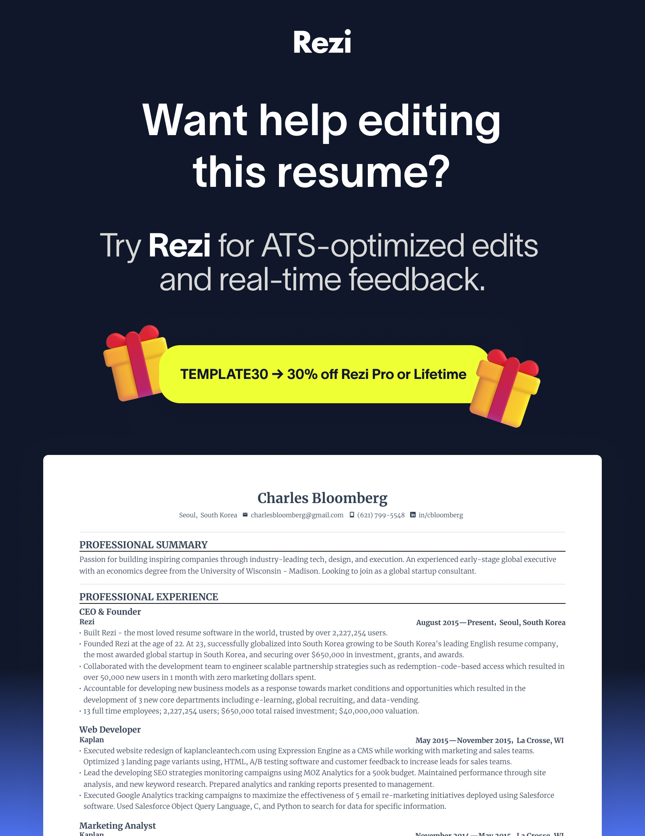
Charles Bloomberg
Seoul, South Korea  charlesbloomberg@gmail.com  (621) 799-5548  in/cbloomberg
PROFESSIONAL SUMMARY
Passion for building inspiring companies through industry-leading tech, design, and execution. An experienced early-stage global executive with an economics degree from the University of Wisconsin - Madison. Looking to join as a global startup consultant.
EXPERIENCE
CEO & Founder
Rezi August 2015—Present, Seoul, South Korea
- Built Rezi - the most loved resume software in the world, trusted by over 4,124,000 users.
- Founded Rezi at the age of 22. At 23, successfully globalized into South Korea growing to be South Korea's leading English resume company, the most awarded global startup in South Korea, and securing over $650,000 in investment, grants, and awards.
- Collaborated with the development team to engineer scalable partnership strategies such as redemption-code-based access which resulted in over 50,000 new users in 1 month with zero marketing dollars spent.
- Accountable for developing new business models as a response towards market conditions and opportunities which resulted in the development of 3 new core departments including e-learning, global recruiting, and data-vending.
- 16 full time employees; 4,123,390 users; $650,000 total raised investment; $38,000,000 valuation.

Web Developer
Kaplan May 2015—November 2015, La Crosse, WI
- Executed website redesign of kaplancleantech.com using Expression Engine as a CMS while working with marketing and sales teams. Optimized 3 landing page variants using, HTML, A/B testing software and customer feedback to increase leads for sales teams.
- Lead the developing SEO strategies monitoring campaigns using MOZ Analytics for a 500k budget. Maintained performance through site analysis, and new keyword research. Prepared analytics and ranking reports presented to management.
- Executed Google Analytics tracking campaigns to maximize the effectiveness of 5 email re-marketing initiatives deployed using Salesforce software. Used Salesforce Object Query Language, C, and Python to search for data for specific information.

Marketing Analyst
Kaplan November 2014—May 2015, La Crosse, WI
- Relied and implement Tableau dashboards to track 6 marketing KPIs. Used data to create reports circulated amongst leadership. Collaborated with marketing specialists to improve marketing strategies to maximize ROI such as introducing Facebook retargeting.
- Used SurveyMonkey to collect over 100 customer feedbacks used to conduct analysis, identify market trends, and calculate NPS. Used customer feedback data and optimization software to present and suggest website improvements to management.
- Managed mobile 2 PPC strategy efforts, using Google AdWords Editor and Marin, by teaching marketing specialists best practices.

Web Development Intern
Wisconsin Public Television June 2012—September 2012, Madison, WI
- Integrated Analytics and marketing pixels to track behavior when introducing promos which brought in over $235k in sales.
PROJECT
Early-Stage Startup Architect
Independent Startup Consultant • <nil>
- Worked with 3 global founders to bring well-executed MVPs to market through no-code and "ship-first" methodologies.
- Worked with 3 global founders to bring well-executed MVPs to market through no-code and "ship-first" methodologies.
- Worked with 3 global founders to bring well-executed MVPs to market through no-code and "ship-first" methodologies.
- Worked with 3 global founders to bring well-executed MVPs to market through no-code and "ship-first" methodologies.
EDUCATION
Bachelor of Science in Economics with a Mathematics Emphasis
University of Wisconsin - Madison • Powers-Knapp Scholar • 2014
SKILLS
Leadership: Speaking, Fundraising, Product Development, Communication, Partnerships, International Marketing

Front End: HTML, CSS, Bootstrap, Webflow | Design: Photoshop, Illustrator, Sketch

Fields of Interest: Early-Stage Fundraising, Global Entrepreneurship, Web Design, Growth

